## Qwen3-VL-8B-Instruct 部署验证交付
### 1. 使用权重
- 模型：`Qwen3-VL-8B-Instruct`
- 路径：`/workspace/shared_assets/models/Qwen/Qwen3-VL-8B-Instruct`（服务器预置，17GB）
- dtype：bfloat16（未量化）
### 2. 部署脚本（关键命令）
```bash
# 启动服务
export VLLM_USE_MODELSCOPE=True
export PYTORCH_NPU_ALLOC_CONF=max_split_size_mb:256
nohup vllm serve /workspace/shared_assets/models/Qwen/Qwen3-VL-8B-Instruct \
--dtype bfloat16 \
--max-model-len 16384 \
--max-num-batched-tokens 16384 \
> /workspace/vllm_serve.log 2>&1 &
服务成功启动关键日志：
(EngineCore pid=25941) INFO ... Starting to load model ...
Loading safetensors checkpoint shards: 100% Completed | 4/4 [05:18<00:00, 79.51s/it]
(APIServer pid=25085) INFO: Started server process [25085]
(APIServer pid=25085) INFO: Application startup complete.

3. 功能验证（curl 推理）
请求：
curl http://localhost:8000/v1/chat/completions \
-H "Content-Type: application/json" \
-d '{
"model": "/workspace/shared_assets/models/Qwen/Qwen3-VL-8B-Instruct",
"messages": [
{"role": "system", "content": "You are a helpful assistant."},
{"role": "user", "content": [
{"type": "image_url", "image_url": {"url": "https://modelscope.oss-cn-beijing.aliyuncs.com/resource/qwen.png"}},
{"type": "text", "text": "What is the text in the illustration?"}
]}
]
}'
响应（关键片段）：
{
"id": "chatcmpl-99205e26e2eaaecf",
"choices": [{
"index": 0,
"message": {
"role": "assistant",
"content": "TONGYI Qwen"
},
"finish_reason": "stop"
}],
"usage": {"prompt_tokens": 107, "completion_tokens": 7, "total_tokens": 114}
}

4. 性能测试（vLLM Benchmark）

4.1 测试 1：低负载（20 prompts, concurrency=4, RPS=4）
命令：
vllm bench serve \
--backend openai-chat \
--model /workspace/shared_assets/models/Qwen/Qwen3-VL-8B-Instruct \
--endpoint /v1/chat/completions \
--dataset-name random-mm \
--random-mm-bucket-config '{"(256, 256, 1)": 0.5, "(720, 1280, 1)": 0.5, "(720, 1280, 16)": 0.0}' \
--random-mm-base-items-per-request 1 \
--random-input-len 128 \
--random-output-len 64 \
--num-prompts 20 \
--max-concurrency 4 \
--request-rate 4
结果：
============ Serving Benchmark Result ============
Successful requests: 20
Failed requests: 0
Request throughput (req/s): 1.70
Output token throughput (tok/s): 108.72
Peak output token throughput (tok/s): 144.00
Total token throughput (tok/s): 326.15
Mean TTFT (ms): 375.68
Median TTFT (ms): 390.34
P99 TTFT (ms): 580.93
Mean TPOT (ms): 29.72
Median TPOT (ms): 28.44
P99 TPOT (ms): 34.15
Mean ITL (ms): 29.91
Median ITL (ms): 28.08
P99 ITL (ms): 118.51
==================================================

4.2 测试 2：较高负载（50 prompts, concurrency=8, RPS=8）
命令：
vllm bench serve \
--backend openai-chat \
--model /workspace/shared_assets/models/Qwen/Qwen3-VL-8B-Instruct \
--endpoint /v1/chat/completions \
--dataset-name random-mm \
--random-mm-bucket-config '{"(256, 256, 1)": 0.5, "(720, 1280, 1)": 0.5, "(720, 1280, 16)": 0.0}' \
--random-mm-base-items-per-request 1 \
--random-input-len 256 \
--random-output-len 128 \
--num-prompts 50 \
--max-concurrency 8 \
--request-rate 8
结果：
============ Serving Benchmark Result ============
Successful requests: 50
Failed requests: 0
Request throughput (req/s): 1.63
Output token throughput (tok/s): 208.08
Peak output token throughput (tok/s): 288.00
Total token throughput (tok/s): 624.24
Mean TTFT (ms): 451.56
Median TTFT (ms): 437.30
P99 TTFT (ms): 848.53
Mean TPOT (ms): 31.71
Median TPOT (ms): 31.75
P99 TPOT (ms): 33.46
Mean ITL (ms): 32.31
Median ITL (ms): 28.41
P99 ITL (ms): 154.34
==================================================

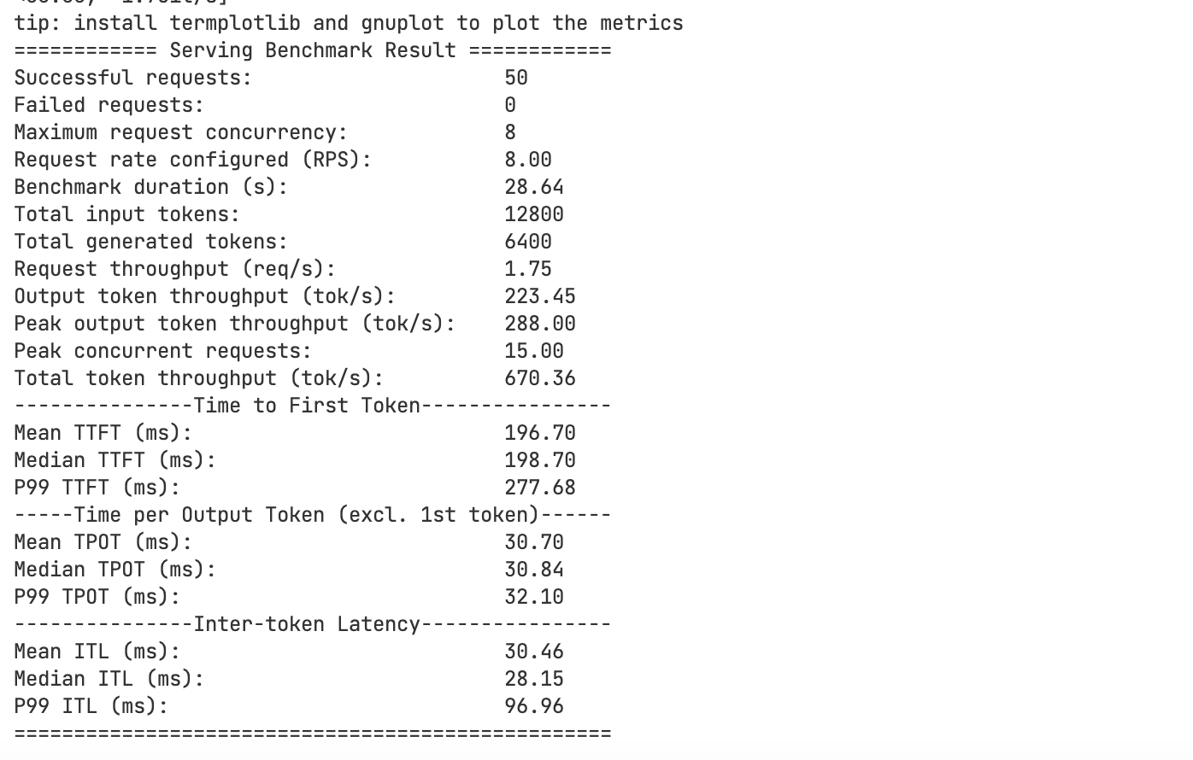

5. 资料使用感受
参考文档：Qwen-VL-Dense (Qwen2.5VL-3B/7B, Qwen3-VL-2B/4B/8B/32B) — vllm-ascend
指标 | 评分（满分 5） | 说明
完整性 | 5 | 涵盖环境准备、依赖安装、离线推理、在线服务、curl 测试，步骤链完整
易用性 | 4 | 命令可直接复制使用；但环境变量和路径细节需用户根据实际替换
正确性 | 4 | 主体内容正确，但多模态 benchmark 部分缺少 backend 说明

6. 全程问题记录与解决方案
# | 问题 | 解决方案
1 | vllm bench serve 默认 backend (vllm) 不支持多模态数据集，运行时 ValueError: Multi-modal content (images) is only supported on 'openai-chat' backend. | 添加 --backend openai-chat 参数
2 | 服务启动时 Loading safetensors checkpoint shards: 0% Completed 长时间不刷新（实际是异步加载 + ACL Graph 编译，约 5 分钟） | 通过 npu-smi info 观察 HBM 占用从 0 增长到 ~58G 即可确认进程正常

7. 社区文档问题与建议
问题：Qwen-VL-Dense 文档性能测试章节未明确说明多模态 benchmark 必须使用 openai-chat 后端，初次按文档执行会直接报错。
建议修正：在文档"性能测试"章节补充以下内容：
# 多模态 benchmark 必须使用 openai-chat 后端
vllm bench serve \
--backend openai-chat \
--model <MODEL_PATH> \
--endpoint /v1/chat/completions \
--dataset-name random-mm \
--random-mm-bucket-config '{"(256, 256, 1)": 0.5, "(720, 1280, 1)": 0.5, "(720, 1280, 16)": 0.0}' \
--random-mm-base-items-per-request 1 \
--random-input-len 256 \
--random-output-len 128 \
--num-prompts 50 \
--max-concurrency 8

8. 最终结论
✅ 测试通过。Qwen3-VL-8B-Instruct 在单卡 Atlas 800I A2 (910B3) 上：
- 离线/在线推理功能正常，输出与社区文档示例一致
- 8 并发下输出吞吐 208.08 tok/s，TPOT 中位数 31.75 ms
- 50 个 benchmark 请求全部成功（失败率 0）
- 部署流程与社区文档主体一致，仅 benchmark 部分需补全 backend 说明

